TRAFIC

Duration: 15 min
Format : 35mm / Color / Fiction
Genre : Drama

Year : 2003
Country : Romania

Director
Catalin MITULESCU

Writers
Catalin MITULESCU & Andrea VALEAN

Editor
Ion Ioachim STROE

Cast

Tudor…Bogdan DUMITRACHE

The girl…Maria DINULESCU

Production Company
LEFT PICTURES

International Sales
PREMIUM FILMS

Synopsis

On his way to the next business meeting, Tudor has 20 minutes a break. Enough time to invite a girl to drink a coffee, talk about his daughter and make a photo.

PALME D’OR

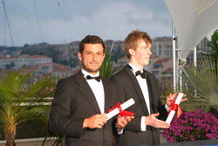

du court-métrage
CANNES 2004

